**User Guide**

The program I plan to construct is for the local DHB (District Health Board) in order to record the Covid-19 injections. The program will be used by the operators at the vaccination centres all over New Zealand so that recording the injections will be more efficient by making it easier for operators to determine whether a person has already gotten the doses of the Covid-19 vaccine or not.

The format below is for the operator to use to get the information by searching for the patients NHI number as well as enter any new information (such as a person without a NHI number or changing a person's address). This program can be used by anyone but is specifically made for the operators at the Covid-19 Vaccination Centres.

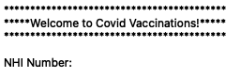

First the program will need to be opened to start. The NHI number of the patient will be asked for when the program starts. If the NHI number isn’t in the system, the operator is able to add new details for a person and add them to the file. The operator will then be asked to restart the program in order to continue.

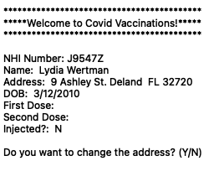

When the operator types in the NHI number of the patient, their details will be printed which includes their name, address, DOB, what date they have gotten the first dose and what date the second dose is on as well as another line that prints whether the patient has gotten both vaccines or not. The operator will then be asked if they want to change the address, if yes, the operator will be able to enter the address, the new address will then print, and the program will continue running.

The age of the patient will then be checked automatically by the program by using the current date as well as the patients date of birth. If the age is less than 16, a statement saying that the patient is too young will print and the program will stop running. If the age is more than 16, the statement will say that the patient is able to receive the vaccine and the program will continue to run.

The operator will then be asked if the patient got their first dose, if no, a statement would print saying that the patient is eligible for two doses. If yes, the program will print today's date as well as the date (21 days later) for the second dose and another statement asking the patient to return to the vaccination centre on this date. All the information will then be saved to the original file.

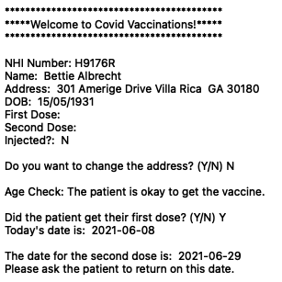

**The operator will be asked to enter Y or N (for yes or no) in order to answer the questions. Using Y and N is efficient for the operators. If the operator makes a mistake and accidentally enters the wrong letter, the question will be repeated which makes the program easier for the operator to use.**

***There are still restrictions with this program.***

During the entering new data process, the operator will have to restart the program in order to continue the program. This is a big inconvenience.

When entering the new address, the operator will have to make sure to type in the correct address as there is no database of addresses in Auckland to be accessed and referred to.